OBJECT ORIENTED PROGRAMMING PROJECT
DAVID RAPHAEL MULULU
ENE211-0173/2024

VEHICLE RENTING SYSTEM
INTRODUCTION
With the increasing demand for convenient and efficient transportation services, vehicle rental business is becoming an important part of modern mobility solutions. This has proved to be useful in functions such as funeral services, weddings, transportation and construction. Managing rental operations manually can lead to challenges such as inaccurate record keeping, inefficient vehicle tracking, book conflicts and difficulty in calculating rental charges. To solve this challenges, computerized management systems need to be adopted to improve customer service.
This project presents the design and implementation of a Vehicle Rental Management System. The system is designed to automate the activities involved in the vehicle renting operations which include; vehicle registration, customer management, vehicle booking, rental charge calculation and vehicle return processing.
The project applies the four fundamental pillars of object-oriented programming which are; encapsulation, abstraction, inheritance, and polymorphism. Different vehicles such as cars, bikes and trucks are represented as derived classes from a parent class vehicle allowing the system to handle multiple vehicles categories efficiently.
FUNCTIONAL REQUIREMENTS
The vehicle rental management system will provide the following functionalities:
- Vehicle management
- Add new vehicles in the system
- Update vehicle information such as model, registration number, rental price, and availability status.
- Remove vehicle records when necessary
- Customer management
- Register new customers
- Update customer information
- Display customer records
- Vehicle booking and rental
- Allow customers to view available vehicles
- Allow a customer to rent a vehicle
- Assign a selected vehicle to a customer
- Mark rented vehicle as unavailable
- Vehicle returning processing
- Record returned vehicles
- Update availability after return
- Calculate total rental charges based on rental duration
- Apply additional charges for late returns if applicable
- Rental records management
- Store rental transaction records
- Search rental records using customer ID
- Data storage
- Stores vehicle, customer, and rental information
- Retrieve data when the system is restarted
NON-FUNCTIONAL REQUIREMENTS
The vehicle renting management system shall satisfy the following non-functional requirements
- Performance
The system shall process user requests such as vehicle search, booking and record retrieval within an acceptable response time.
The system will be able to handle multiple customers without any significant delays.
- Reliability
The system shall operate consistently without unexpected failures during normal usage.
- Usability
The system shall provide a simple and user-friendly interface that is easy to understand and operate.
- Security
The system shall protect customer information from unauthorized access.
- Portability
The system shall be capable of running on different computer systems that supports applications.
- Availability
The system shall be available for use whenever required during business operations.

SYSTEM ARCHITECTURE
The vehicle rental management system follows a layered architecture consisting of three main components:
- The presentation layer
- Business logic layer
- Data storage layer

- Presentation layer
This layer provides the interface through which users interact with the system. It accepts user inputs and displays system outputs. In this project, the presentation layer is implemented using a console-based interface developed in.
The functions performed in this layer include:
- Displaying menus
- Accepting user inputs
- Showing vehicle details
- Displaying rental records
- Showing payment information

- Business logic layer
This layer contains the core functionality of the system. It processes user requests, applies business rules, and manages interactions between user interface and stored data.
Major operations include:
- Vehicle registration and management
- Customer registration
- Vehicle booking and rental processing
- Return fee calculation
- Return processing
- Record validating

- Data storage layer
This layer is responsible for storing and retrieving system data. Data stored include:
- Vehicle information
- Customer details
- Rental records
- Payment records

SYSTEM BLOCK DIAGRAM

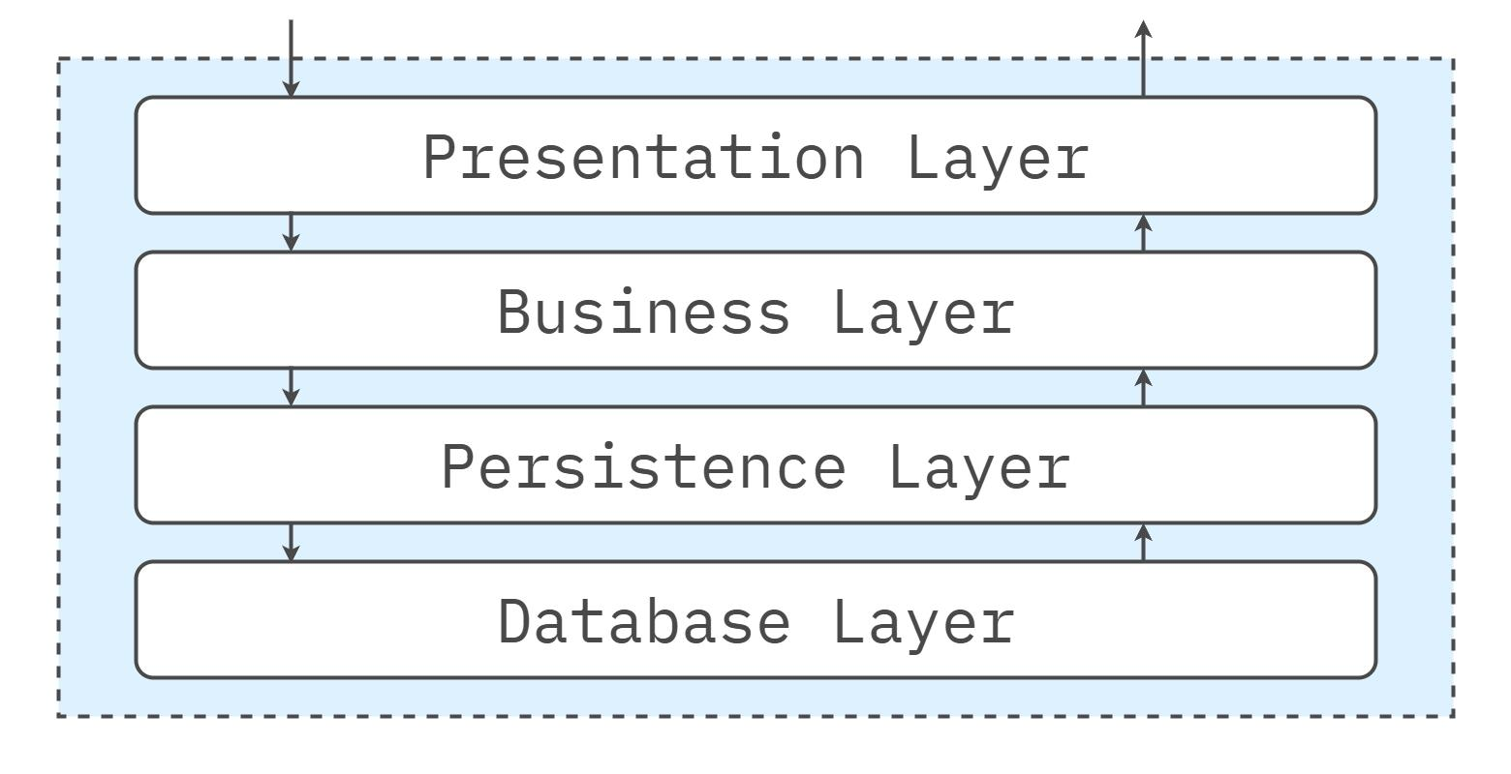

Implementation of OOP pillars
- Encapsulation
Data fields such as vehicle registration numbers, rental car rates, and customer personal details are declared as private or protected within their respective classes. Access to and modification of these attributes is only to authorized public getter and setter methods. This prevents unauthorized direct data manipulation and maintains data integrity across the system layers.
- Abstraction
An abstract class is used to hide complex operational details from the user. For instance, the process of calculating the rental charges and managing availability statuses is hidden behind a simple public interface method.
The presentation layer interacts with these methods without needing to understand the underlying algorithm logic.
- Inheritance
A general base class is created to contain shared attributes. A base class vehicle can share attributes like registration number, model, rental price.
- Polymorphism
Polymorphism is applied through overriding. The base class Vehicle defines a virtual method calculaterent. Each derived class overrides this method to apply specific billing logic, allowing the system to process a collection of mixed vehicles types dynamically.
DATABASE DESIGN
- Vehicle table structure
This table stores details about each vehicle
Field name | Data type | description
registration number | VARCHAR(20) | Unique identifier for the vehicle
brand | VARCHAR(50) | Brand of the vehicle
model | VARCHAR(50) | Model of the vehicle
daily_rate | DECIMAL(10,2) | Daily rental rate for the vehicle
availability_status | BOOLEAN | Available (true) or not available(false)
type | ENUM | Type of vehicle(Car, truck)
extra_charge | DECIMAL(10,2) | Applicable only for trucks any additional charges

- Customer table structure
This table stores details about each customer.

Field name | Data type | description
id | INT | Unique identifier for the customer
name | VARCHAR(100) | Full name of the customer
phone_number | VARCHAR(15) | Contact phone number of the customer
driving_license_number | VARCHAR(20) | Unique driving license number of the customer

- Rental table structure
This table logs rental transactions
Field name | Data type | Description
rental_id | VARCHAR(20) | Unique transaction for the rental transaction
customer_id | INT | Foreign key referencing the customer table.
vehicle_registration_number | VARCHAR(20) | Foreign key referencing the vehicle table.
rental_date | DATE | Date when the vehicle was rented
return_date | DATE | Expected return date of the vehicle
total_cost | DECIMAL(10,2) | Total cost calculated for the rental period
penalty | DECIMAL(10,2 | Penalty calculated if returned late

SYSTEM OUTPUT
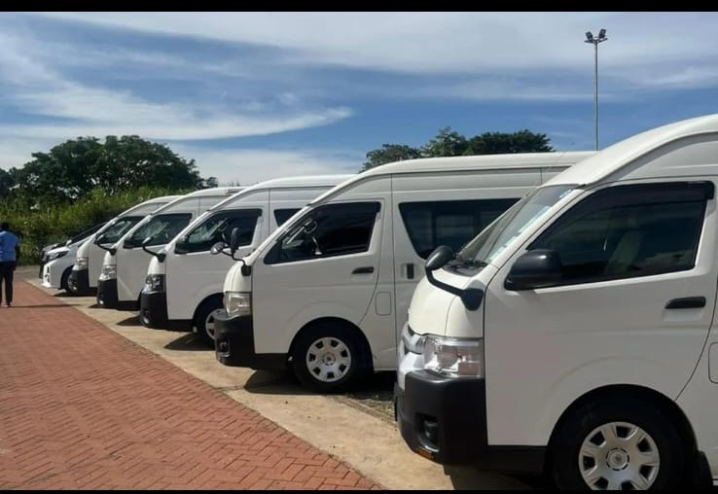
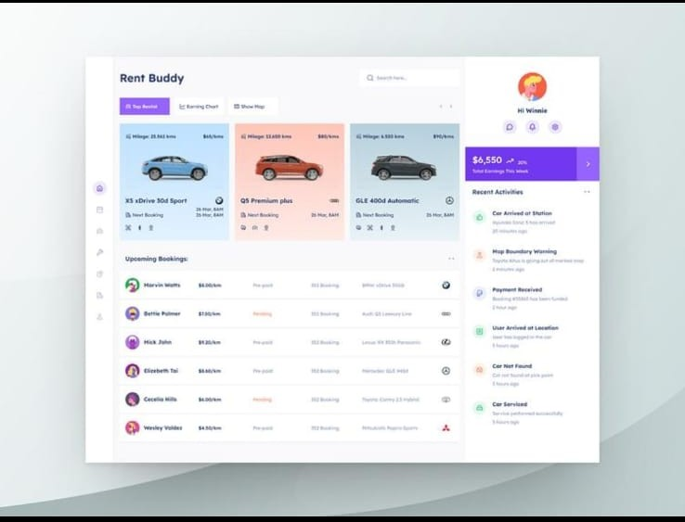


CONCLUSION
The computerized Vehicle Rental Management system successfully replaces error-prone manual record keeping with a reliable automated platform. By structuring the application into clear presentation, business logic, and data storage layers, the system guarantees ease of maintenance and clear tracking of assets. Furthermore, implementing fundamental OOP principles ensures that adding new vehicle categories or scaling up business logic that can be achieved with minimal structural alterations to the core codebase.

